Elliptical-Curve Generator

Definition
# Source: AI Source: Provided by: [Data Path: Persons Table -> ID Column: 1, Name_En Column: Motasem Essam] -> From: [ChatGPT] on [7/25/2026]
An Elliptical-Curve Generator is a curved-line generator that uses an elliptical curve as its generating element to produce a geometric surface or solid through a prescribed movement, particularly rotation.
An ellipse is a closed plane curve defined by the condition that the sum of the distances from any point on the curve to two fixed points, called the foci, is constant.
When an elliptical curve rotates around one of its principal axes, it generates a spheroidal surface:
- Rotation around the major axis generates a Prolate Spheroid.
- Rotation around the minor axis generates an Oblate Spheroid.
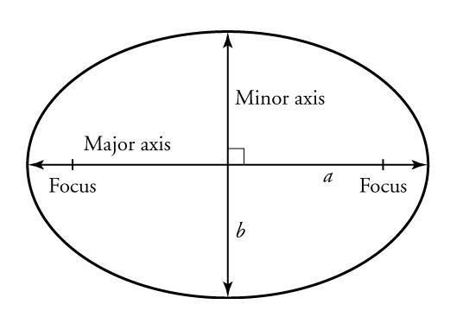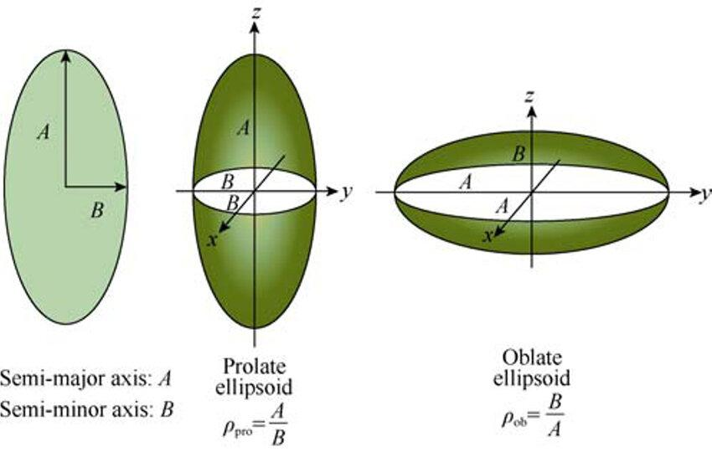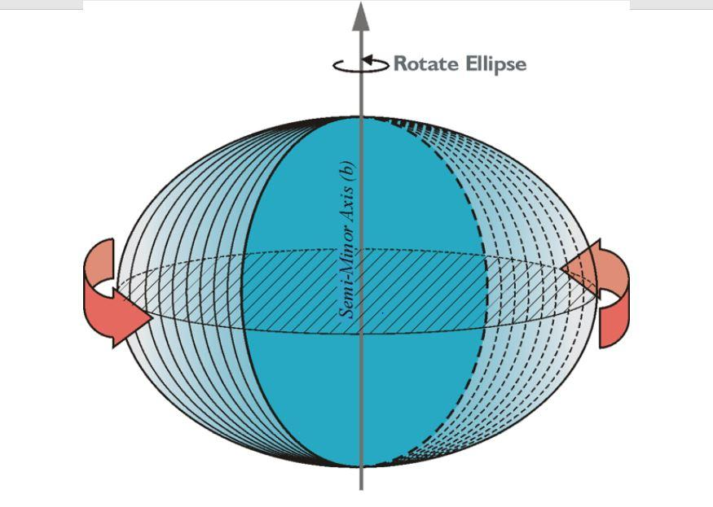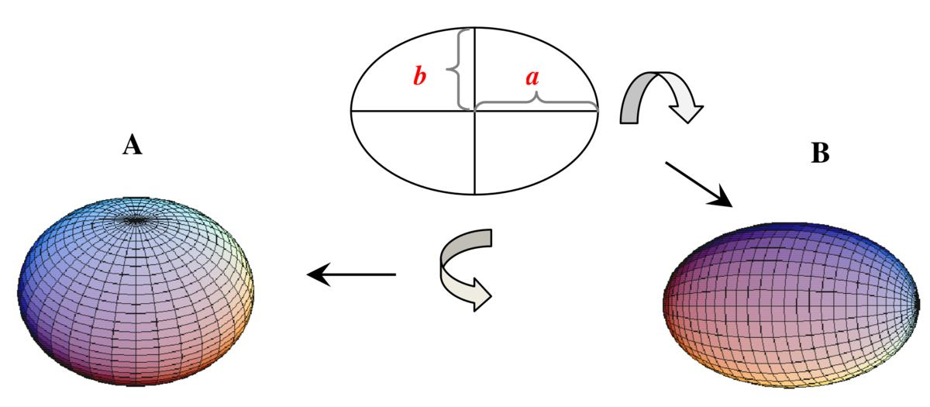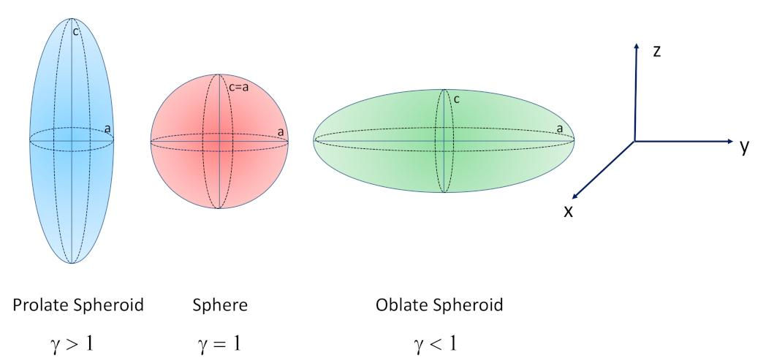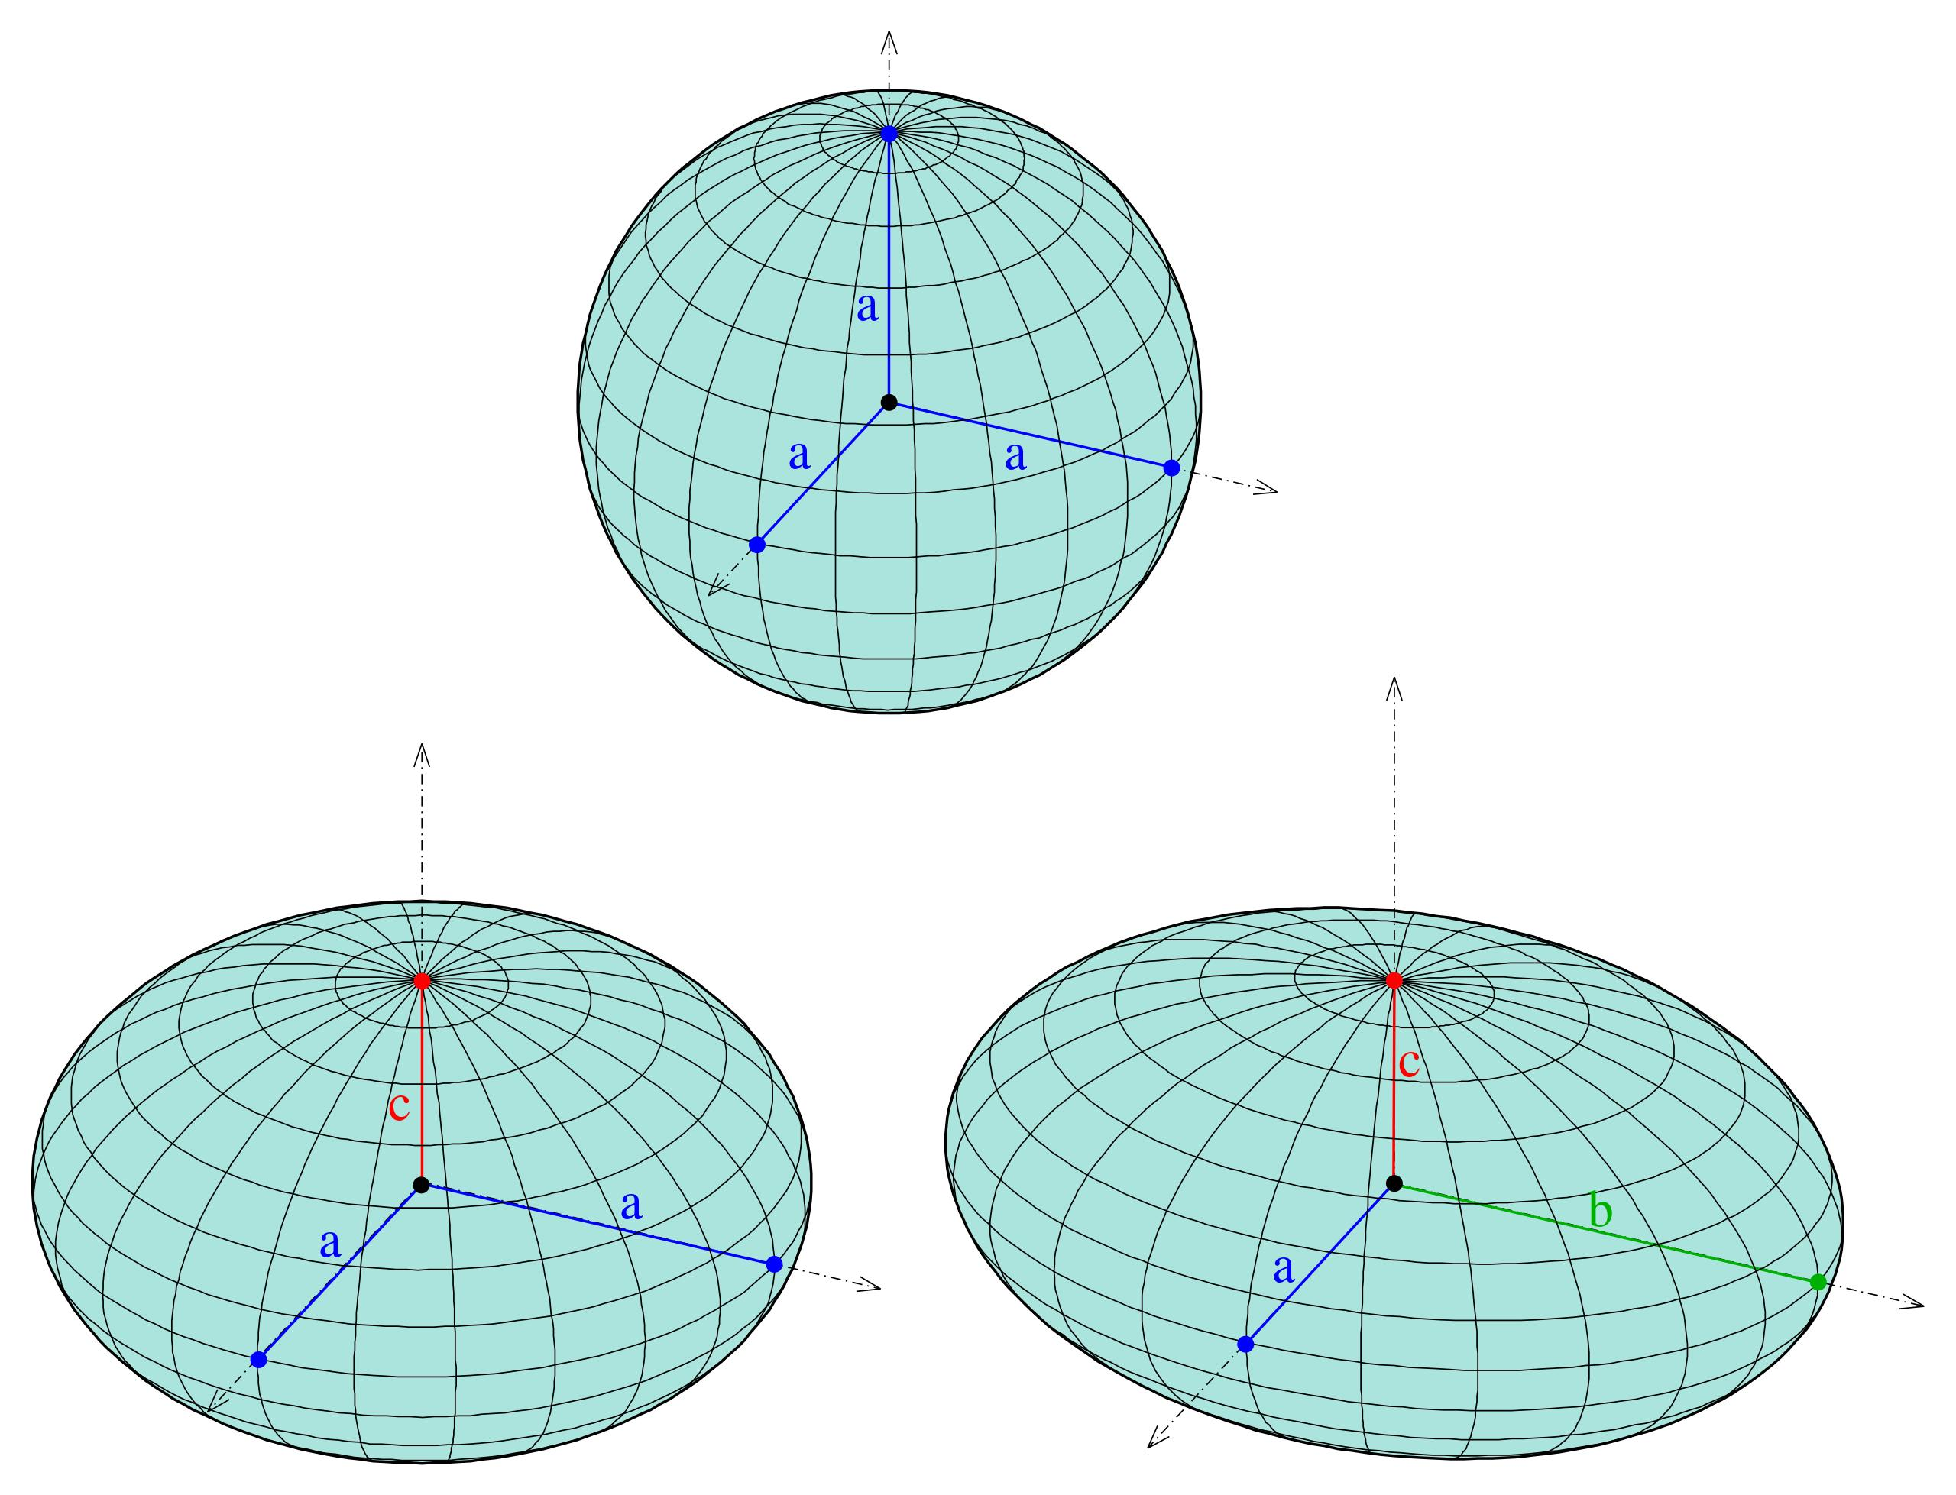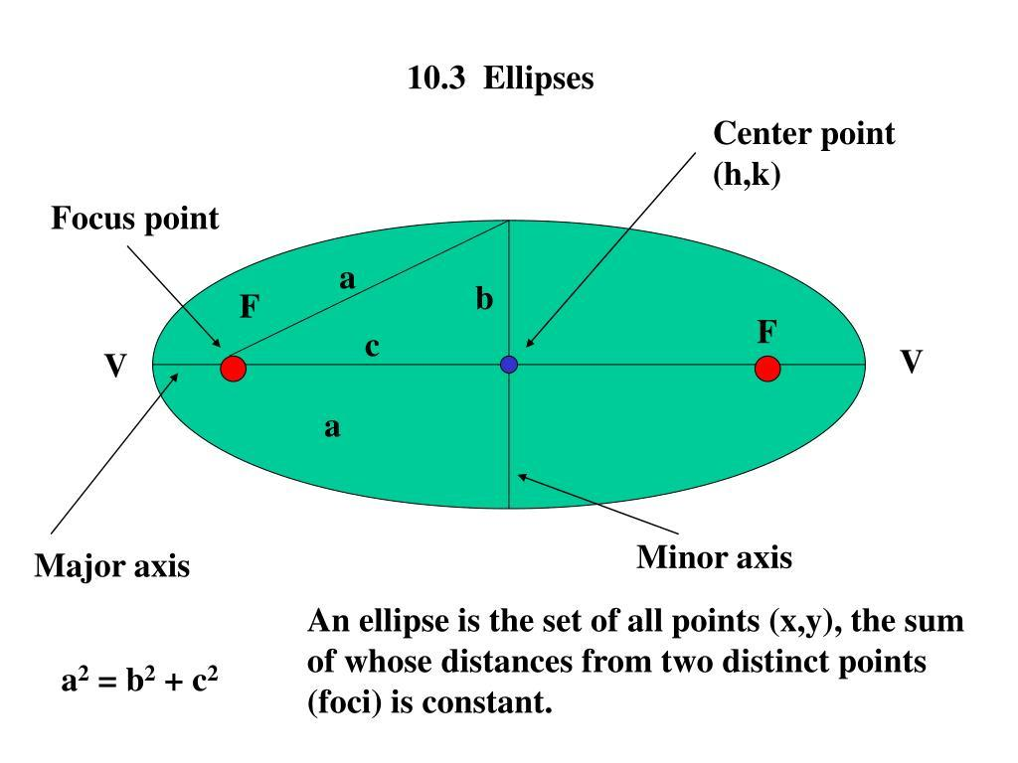

Geometric Structure
# Source: AI Source: Provided by: [Data Path: Persons Table -> ID Column: 1, Name_En Column: Motasem Essam] -> From: [ChatGPT] on [7/25/2026]
An elliptical-curve generator consists of the following elements:
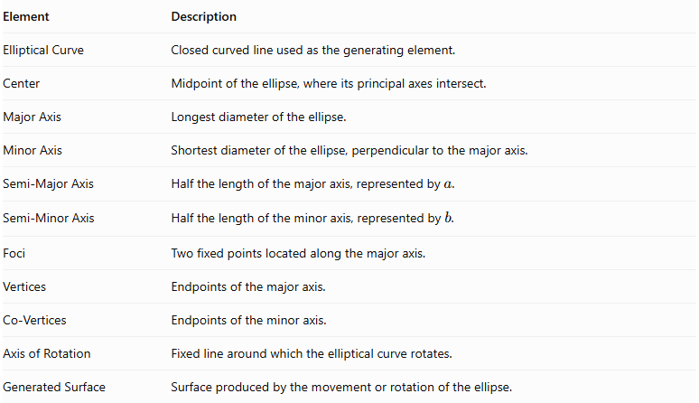
Element | Description
Elliptical Curve | Closed curved line used as the generating element.
Center | Midpoint of the ellipse, where its principal axes intersect.
Major Axis | Longest diameter of the ellipse.
Minor Axis | Shortest diameter of the ellipse, perpendicular to the major axis.
Semi-Major Axis | Half the length of the major axis, represented by $a$.
Semi-Minor Axis | Half the length of the minor axis, represented by $b$.
Foci | Two fixed points located along the major axis.
Vertices | Endpoints of the major axis.
Co-Vertices | Endpoints of the minor axis.
Axis of Rotation | Fixed line around which the elliptical curve rotates.
Generated Surface | Surface produced by the movement or rotation of the ellipse.
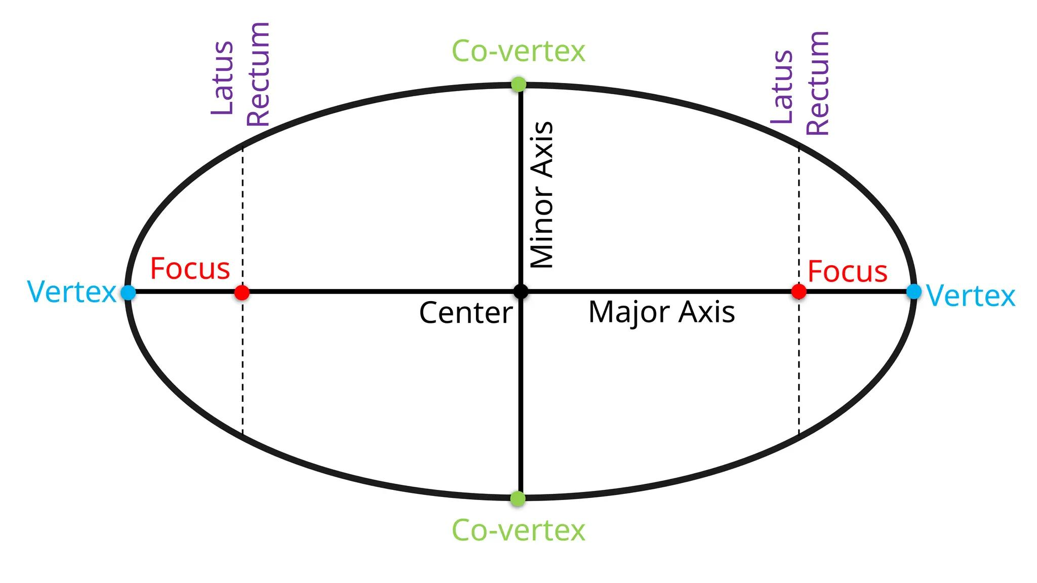

Types of Elliptical Curves
# Source: AI Source: Provided by: [Data Path: Persons Table -> ID Column: 1, Name_En Column: Motasem Essam] -> From: [ChatGPT] on [7/25/2026]
Elliptical curves can be classified according to the relationship between their semi-major and semi-minor axes.

Horizontal Ellipse
# Source: AI Source: Provided by: [Data Path: Persons Table -> ID Column: 1, Name_En Column: Motasem Essam] -> From: [ChatGPT] on [7/25/2026]
A Horizontal Ellipse is an ellipse whose major axis is parallel to the horizontal $x$-axis.
Its standard equation, centered at the origin, is:
$$\boxed{\frac{x^{2}}{a^{2}}+\frac{y^{2}}{b^{2}}=1}$$
where $a>b$.
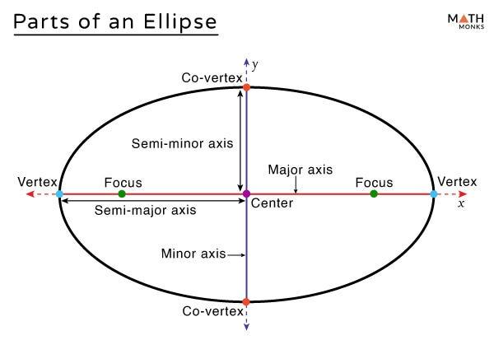

Vertical Ellipse
# Source: AI Source: Provided by: [Data Path: Persons Table -> ID Column: 1, Name_En Column: Motasem Essam] -> From: [ChatGPT] on [7/25/2026]
A Vertical Ellipse is an ellipse whose major axis is parallel to the vertical $y$-axis.
Its standard equation is:
$$\boxed{\frac{x^{2}}{b^{2}}+\frac{y^{2}}{a^{2}}=1}$$
where $a>b$.
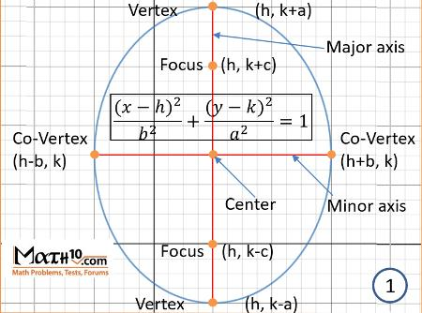

Circular Ellipse
# Source: AI Source: Provided by: [Data Path: Persons Table -> ID Column: 1, Name_En Column: Motasem Essam] -> From: [ChatGPT] on [7/25/2026]
A Circular Ellipse is the special case of an ellipse in which the major and minor axes have equal lengths.
$$a=b=r$$
Its equation is:
$$x^{2}+y^{2}=r^{2}$$
It is a circle and generates a sphere when rotated about a diameter.
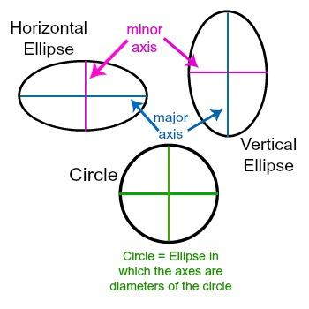

Types According to the Axis of Rotation
# Source: AI Source: Provided by: [Data Path: Persons Table -> ID Column: 1, Name_En Column: Motasem Essam] -> From: [ChatGPT] on [7/25/2026]
When an elliptical curve rotates around one of its principal axes, it generates different types of spheroids.

Rotation About the Major Axis
# Source: AI Source: Provided by: [Data Path: Persons Table -> ID Column: 1, Name_En Column: Motasem Essam] -> From: [ChatGPT] on [7/25/2026]
When an ellipse rotates around its major axis, it generates a Prolate Spheroid.
Generated surface: Prolate Spheroid.
Characteristics:
- The rotation axis coincides with the major axis.
- The resulting solid is elongated along its axis of rotational symmetry.
- The equatorial radius is smaller than the polar radius.
- It resembles an elongated sphere.
Mathematical equation:
$$\boxed{\frac{x^{2}}{a^{2}}+\frac{y^{2}}{b^{2}}+\frac{z^{2}}{b^{2}}=1}$$
where $a>b$, with the $x$-axis as the rotation axis.

Rotation About the Minor Axis
# Source: AI Source: Provided by: [Data Path: Persons Table -> ID Column: 1, Name_En Column: Motasem Essam] -> From: [ChatGPT] on [7/25/2026]
When an ellipse rotates around its minor axis, it generates an Oblate Spheroid.
Generated surface: Oblate Spheroid.
Characteristics:
- The rotation axis coincides with the minor axis.
- The resulting solid is flattened along its axis of rotational symmetry.
- The equatorial radius is greater than the polar radius.
- It resembles a flattened sphere.
Mathematical equation:
$$\boxed{\frac{x^{2}}{a^{2}}+\frac{y^{2}}{a^{2}}+\frac{z^{2}}{b^{2}}=1}$$
where $a>b$, with the $z$-axis as the rotation axis.

Mathematical Representation
# Source: AI Source: Provided by: [Data Path: Persons Table -> ID Column: 1, Name_En Column: Motasem Essam] -> From: [ChatGPT] on [7/25/2026]
Consider an ellipse centered at the origin, with its major axis along the $x$-axis.
Its standard equation is:
$$\boxed{\frac{x^{2}}{a^{2}}+\frac{y^{2}}{b^{2}}=1}$$
Where:
- $a$: Semi-major axis.
- $b$: Semi-minor axis.
- $a>b>0$.

Parametric Equation of the Ellipse
# Source: AI Source: Provided by: [Data Path: Persons Table -> ID Column: 1, Name_En Column: Motasem Essam] -> From: [ChatGPT] on [7/25/2026]
$$x=acost$$
$$y=bsint$$
where:
$$0≤t<2π$$

Prolate Spheroid Representation
# Source: AI Source: Provided by: [Data Path: Persons Table -> ID Column: 1, Name_En Column: Motasem Essam] -> From: [ChatGPT] on [7/25/2026]
Rotating the ellipse around its major axis produces:
$$\boxed{beginalignedx\&=acost\backslash y\&=bsintcosφ\backslash z\&=bsintsinφendaligned}$$
Its Cartesian equation is:
$$\boxed{\frac{x^{2}}{a^{2}}+\frac{y^{2}+z^{2}}{b^{2}}=1}$$

Oblate Spheroid Representation
# Source: AI Source: Provided by: [Data Path: Persons Table -> ID Column: 1, Name_En Column: Motasem Essam] -> From: [ChatGPT] on [7/25/2026]
Rotating the ellipse around its minor axis produces:
$$\boxed{beginalignedx\&=acostcosφ\backslash y\&=acostsinφ\backslash z\&=bsintendaligned}$$
Its Cartesian equation is:
$$\boxed{\frac{x^{2}+y^{2}}{a^{2}}+\frac{z^{2}}{b^{2}}=1}$$
In both representations:
$$0≤t<2π, 0≤φ<2π$$

Geometric Measurements and Formulas

Ellipse Measurements
# Source: AI Source: Provided by: [Data Path: Persons Table -> ID Column: 1, Name_En Column: Motasem Essam] -> From: [ChatGPT] on [7/25/2026]
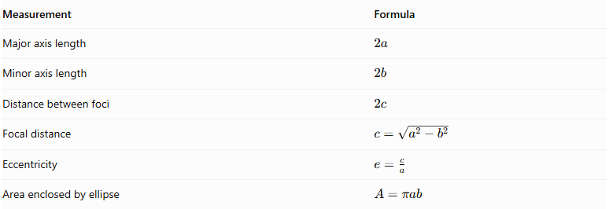
Measurement | Formula
Major axis length | $$2a$$
Minor axis length | $$2b$$
Distance between foci | $$2c$$
Focal distance | $$c=\sqrt{a^{2}-b^{2}}$$
Eccentricity | $$e=\frac{c}{a}$$
Area enclosed by ellipse | $$A=πab$$

Prolate Spheroid Measurements
# Source: AI Source: Provided by: [Data Path: Persons Table -> ID Column: 1, Name_En Column: Motasem Essam] -> From: [ChatGPT] on [7/25/2026]
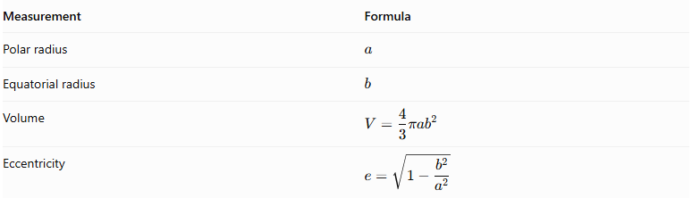
Measurement | Formula
Polar radius | $$a$$
Equatorial radius | $$b$$
Volume | $$displaystyleV=\frac{4}{3}π{ab}^{2}$$
Eccentricity | $$displaystylee=\sqrt{1-\frac{b^{2}}{a^{2}}}$$

Oblate Spheroid Measurements
# Source: AI Source: Provided by: [Data Path: Persons Table -> ID Column: 1, Name_En Column: Motasem Essam] -> From: [ChatGPT] on [7/25/2026]
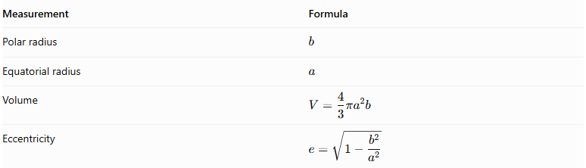
Measurement | Formula
Polar radius | $$b$$
Equatorial radius | $$a$$
Volume | $$displaystyleV=\frac{4}{3}πa^{2}b$$
Eccentricity | $$displaystylee=\sqrt{1-\frac{b^{2}}{a^{2}}}$$
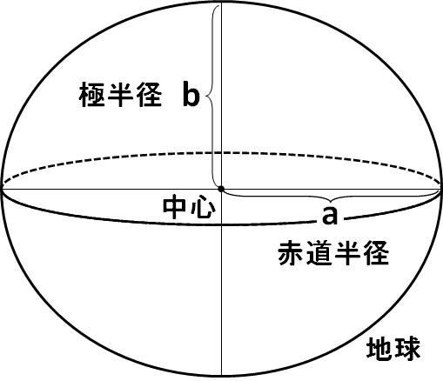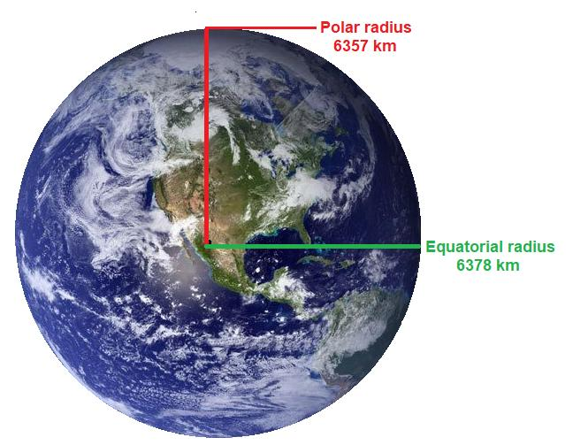

Generated Surfaces and Solids

Prolate Spheroid
# Source: AI Source: Provided by: [Data Path: Persons Table -> ID Column: 1, Name_En Column: Motasem Essam] -> From: [ChatGPT] on [7/25/2026]
A prolate spheroid is an elongated spheroid generated by rotating an ellipse about its major axis.
Examples:
- Rugby-ball-like geometric shape.
- Elongated astronomical bodies approximated by spheroids.

Oblate Spheroid
# Source: AI Source: Provided by: [Data Path: Persons Table -> ID Column: 1, Name_En Column: Motasem Essam] -> From: [ChatGPT] on [7/25/2026]
An oblate spheroid is a flattened spheroid generated by rotating an ellipse about its minor axis.
Examples:
- Approximate geometric model of Earth.
- Flattened planetary bodies.

Sphere
# Source: AI Source: Provided by: [Data Path: Persons Table -> ID Column: 1, Name_En Column: Motasem Essam] -> From: [ChatGPT] on [7/25/2026]
When the generating ellipse has equal semi-axes:
$$a=b=r$$
The ellipse becomes a circle. Rotating it about either principal axis generates a sphere.
$$x^{2}+y^{2}+z^{2}=r^{2}$$
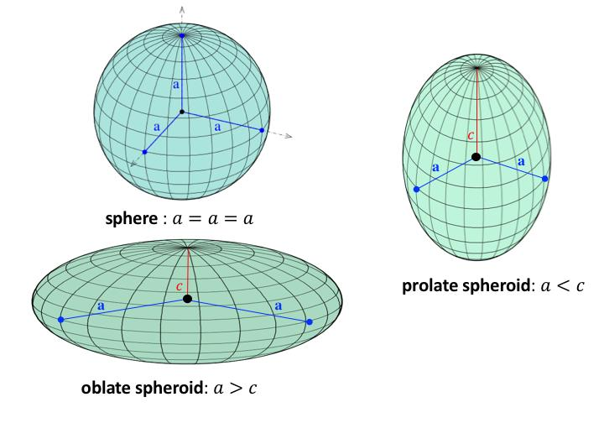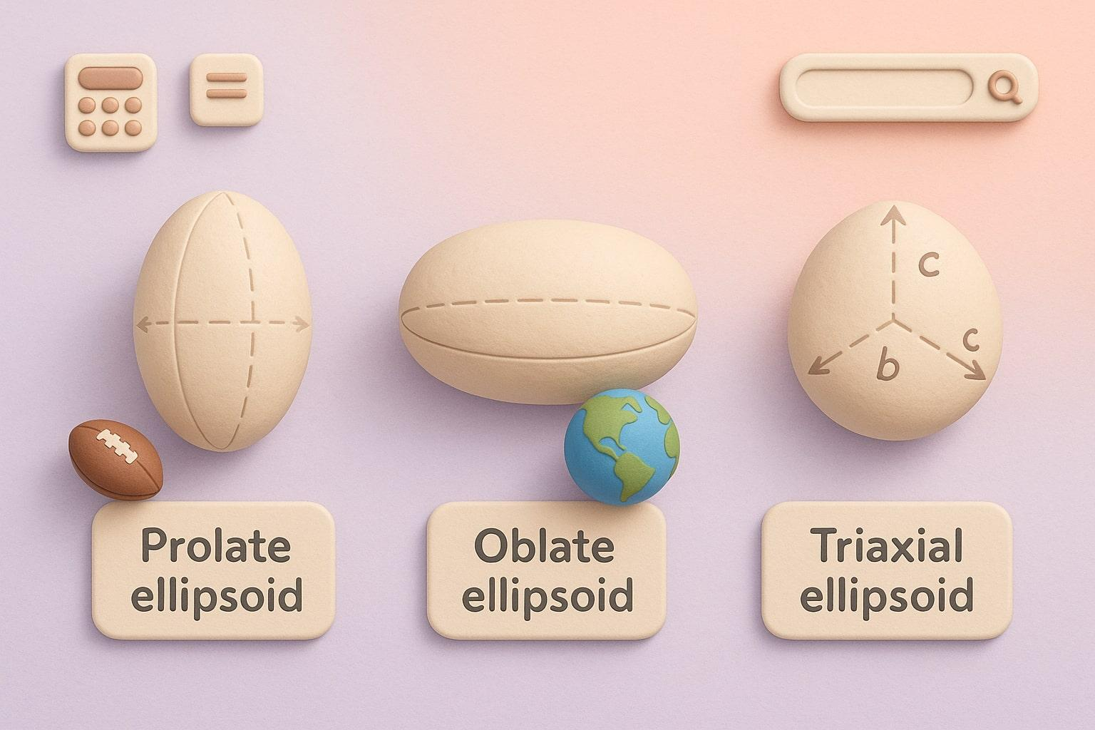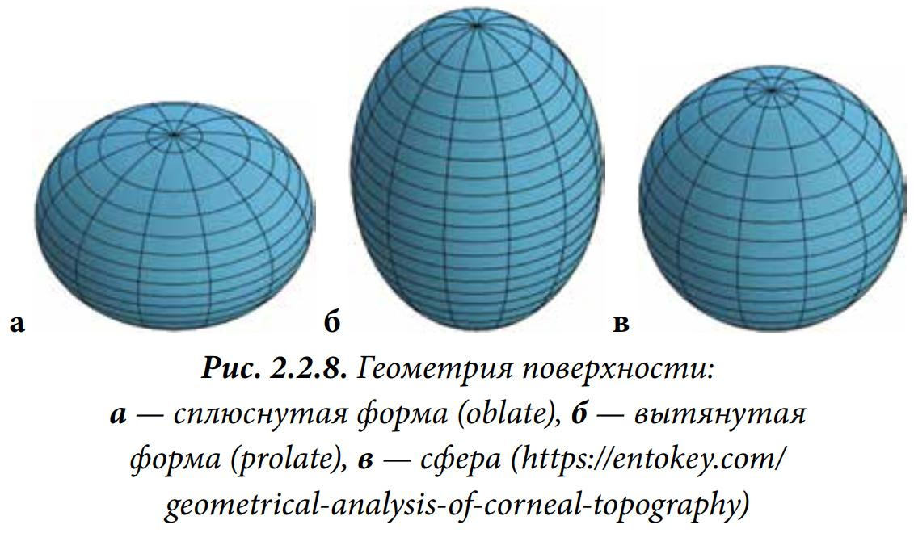

Mathematical Properties
# Source: AI Source: Provided by: [Data Path: Persons Table -> ID Column: 1, Name_En Column: Motasem Essam] -> From: [ChatGPT] on [7/25/2026]
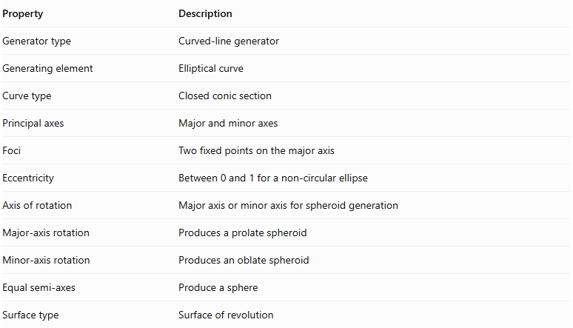
Property | Description
Generator type | Curved-line generator
Generating element | Elliptical curve
Curve type | Closed conic section
Principal axes | Major and minor axes
Foci | Two fixed points on the major axis
Eccentricity | Between 0 and 1 for a non-circular ellipse
Axis of rotation | Major axis or minor axis for spheroid generation
Major-axis rotation | Produces a prolate spheroid
Minor-axis rotation | Produces an oblate spheroid
Equal semi-axes | Produce a sphere
Surface type | Surface of revolution

Important Geometric Distinction
# Source: AI Source: Provided by: [Data Path: Persons Table -> ID Column: 1, Name_En Column: Motasem Essam] -> From: [ChatGPT] on [7/25/2026]
An ellipse rotated about one of its principal axes generates a spheroid, which is a special type of ellipsoid having two equal semi-axes.
A general triaxial ellipsoid has three unequal semi-axes:
$$\boxed{\frac{x^{2}}{a^{2}}+\frac{y^{2}}{b^{2}}+\frac{z^{2}}{c^{2}}=1}$$
where $a$, $b$, and $c$ are all different.
It is not generated by simply rotating an ellipse around one of its principal axes.

Comparison with Other Curved-Line Generators
# Source: AI Source: Provided by: [Data Path: Persons Table -> ID Column: 1, Name_En Column: Motasem Essam] -> From: [ChatGPT] on [7/25/2026]
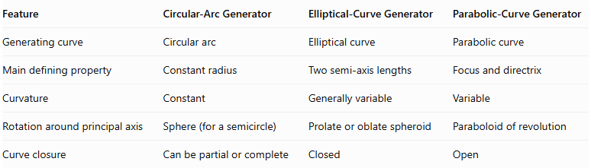
Feature | Circular-Arc Generator | Elliptical-Curve Generator | Parabolic-Curve Generator
Generating curve | Circular arc | Elliptical curve | Parabolic curve
Main defining property | Constant radius | Two semi-axis lengths | Focus and directrix
Curvature | Constant | Generally variable | Variable
Rotation around principal axis | Sphere (for a semicircle) | Prolate or oblate spheroid | Paraboloid of revolution
Curve closure | Can be partial or complete | Closed | Open

Main Classification
# Source: AI Source: Provided by: [Data Path: Persons Table -> ID Column: 1, Name_En Column: Motasem Essam] -> From: [ChatGPT] on [7/25/2026]
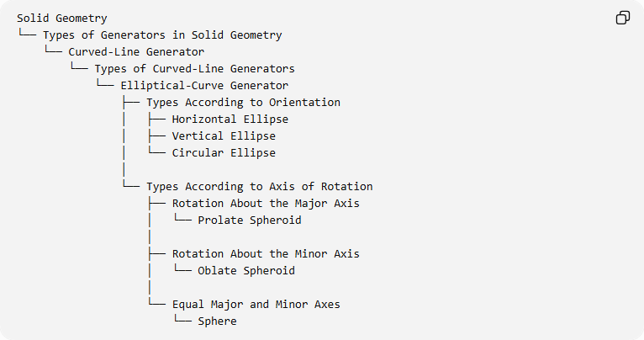
Solid Geometry
└── Types of Generators in Solid Geometry
└── Curved-Line Generator
└── Types of Curved-Line Generators
└── Elliptical-Curve Generator
├── Types According to Orientation
│ ├── Horizontal Ellipse
│ ├── Vertical Ellipse
│ └── Circular Ellipse
│
└── Types According to Axis of Rotation
├── Rotation About the Major Axis
│ └── Prolate Spheroid
│
├── Rotation About the Minor Axis
│ └── Oblate Spheroid
│
└── Equal Major and Minor Axes
└── Sphere

Key Points
# Source: AI Source: Provided by: [Data Path: Persons Table -> ID Column: 1, Name_En Column: Motasem Essam] -> From: [ChatGPT] on [7/25/2026]
- An elliptical-curve generator uses an ellipse as its generating element.
- An ellipse has a major axis, minor axis, center, and two foci.
- Rotating an ellipse around its major axis generates a prolate spheroid.
- Rotating an ellipse around its minor axis generates an oblate spheroid.
- When both semi-axes are equal, the ellipse becomes a circle and generates a sphere.
- A spheroid is a special type of ellipsoid with rotational symmetry.
- A general triaxial ellipsoid is not obtained by simply rotating an ellipse about a principal axis.

Conclusion
# Source: AI Source: Provided by: [Data Path: Persons Table -> ID Column: 1, Name_En Column: Motasem Essam] -> From: [ChatGPT] on [7/25/2026]
The Elliptical-Curve Generator is an important type of curved-line generator used to produce spheroidal surfaces and solids.
Its principal generating operations are rotation around the major and minor axes, producing prolate and oblate spheroids, respectively. It also provides the mathematical foundation for understanding ellipsoids of revolution and their geometric properties.

